1. Introduction
Computer networks enable communication between devices and systems across various distances and environments. Based on their geographical coverage, purpose, and architecture, networks are categorized into multiple types. Below is a deeply researched explanation of all major network types used today.

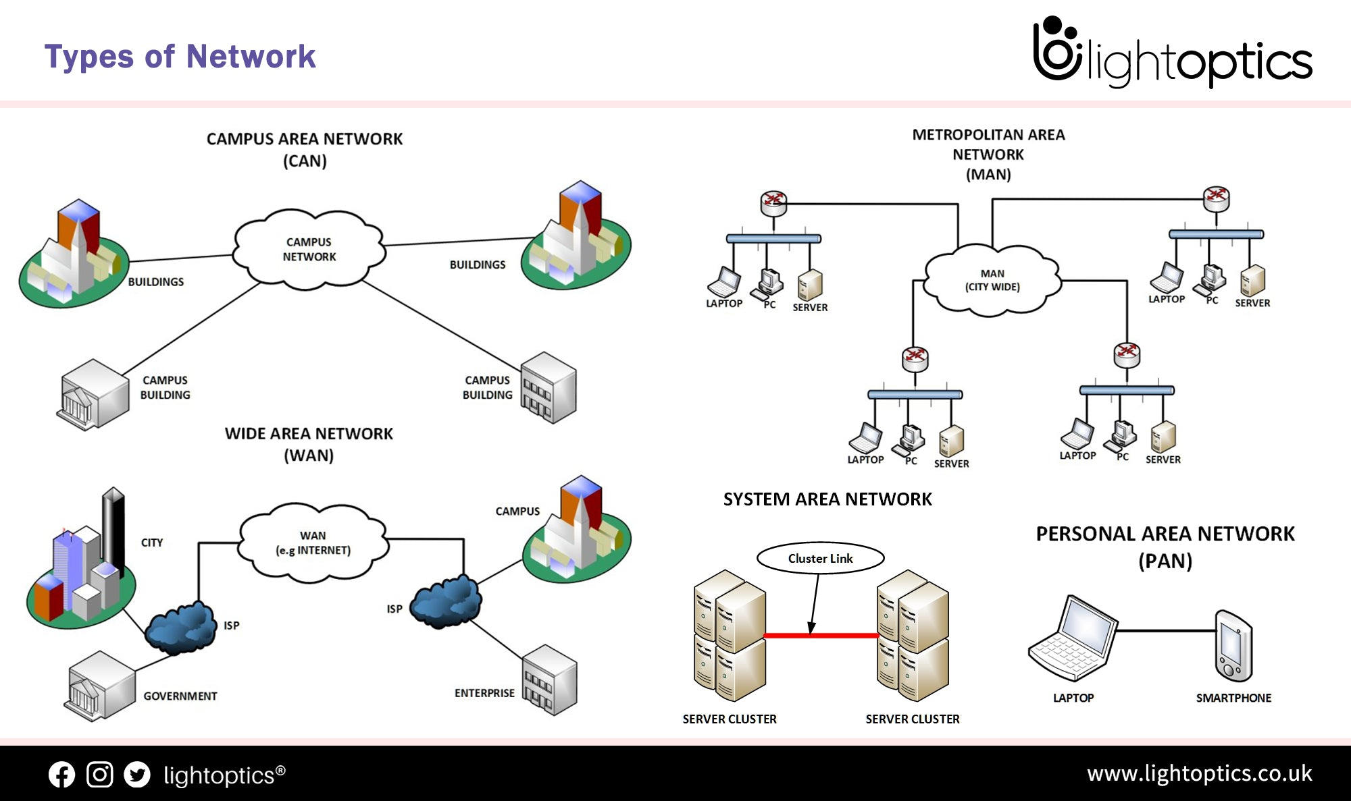

1. PAN — Personal Area Network
A Personal Area Network covers a very short range (typically 1–10 meters) and is used for communication among personal devices.
Characteristics
- Short-range connectivity
- Low power consumption
- Often wireless
Technologies Used
- Bluetooth
- NFC
- Infrared
Examples
- Smartwatch connected to phone
- Bluetooth headphones
- Personal hotspot

2. LAN — Local Area Network
A Local Area Network covers a limited geographical area such as a home, office, school, or lab.
Characteristics
- High speed (100 Mbps – 10 Gbps)
- Privately owned
- Easy maintenance
Technologies Used
- Ethernet
- Wi-Fi
- Switches & Routers
Use Cases
- Office networks
- Home broadband networks

3. WLAN — Wireless LAN
A type of LAN that uses Wi-Fi instead of wired Ethernet.
Characteristics
- Flexible and mobile
- Uses radio waves
- Easy deployment
Use Cases
- Airports, cafés, offices
- Home Wi-Fi networks

4. CAN — Campus Area Network
A CAN interconnects multiple LANs within a campus or institution.
Characteristics
- Larger than LAN; smaller than MAN
- Owned by a single organization
- Fiber-based backbone
Use Cases
- University campus
- Corporate office park
- Military base

5. MAN — Metropolitan Area Network
A MAN covers a city or metropolitan region.
Characteristics
- High-speed fiber-optic links
- Connects multiple LANs
- Often managed by ISPs or governments
Examples
- City-wide broadband
- Cable TV networks

6. WAN — Wide Area Network
WAN spans large geographical areas such as countries or continents.
Characteristics
- Uses public telecom networks
- Lower speed compared to LAN
- High latency
Biggest Example
🌐 The Internet
Technologies
- Submarine fiber cables
- Satellite communication
- MPLS networks
7. IoT Networks (LPWAN, Zigbee, LoRaWAN)
Designed specifically for smart devices that require low power and long-range communication.
Types
- Zigbee — home automation
- LoRaWAN — long-range IoT communication
- NB-IoT — cellular IoT
Use Cases
- Smart homes
- Smart agriculture
- Industrial IoT

8. Enterprise Networks
Used by organizations for large-scale IT operations.
Types within enterprise networking
- Intranet — internal private network
- Extranet — secure external access
- Data center networks
- Campus networks
Technologies
- VLAN
- SD-WAN
- Zero Trust Architecture

9. Cellular Networks (3G, 4G, 5G)
These are mobile communication networks.
Characteristics
- Wide coverage
- Supports mobility
- High scalability
Use Cases
- Smartphones
- IoT devices
- Autonomous vehicles (5G)

